Project Development Phase
Model Performance Test
Date | 07 october 2026
Team ID | SWTID-2026-7050
Project Name | Import Data using Transform Maps
Maximum Marks | 4 Marks

Model Performance Testing:
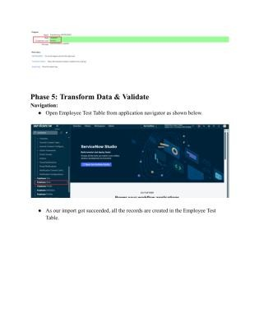
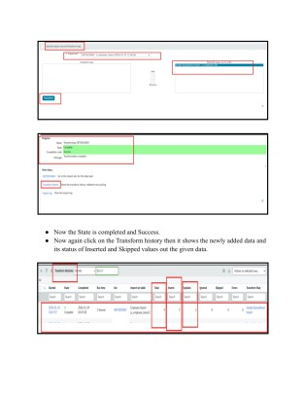
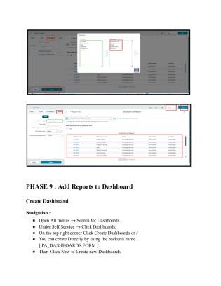
Project team shall fill the following information in model performance testing template.
.No.

Parameter

Values

Screenshot

Model Summary

ServiceNow Import Sets and Transform Maps workflow for
employee data management using an external spreadsheet,
Employee Import staging table, Employee Test target table,
Transform Map, Transform History, reports and Employee
Analytics Dashboard.

Note : If imported data matches the configured mapping and
validation rules, records are transformed into the target table;
otherwise the import/transform history can show unsucce
ssful
rows.

Accuracy

Source
-
supported validation:

• Transform Map field mapping is checked during
transformation.

• Employee Test records are verified after transformation.

• Transform History is reviewed for inserted, updated and
ignored rows.

The

source does not provide a numerical training accuracy or
validation accuracy percentage.

Confidence Score (Only Yolo
Projects)

Not applicable to this project.

The supplied source describes ServiceNow data import,
transformation, validation and repo
rting. It does not use a
YOLO/object
-
detection model and does not define a confidence
score.

Source basis: Import Data using Transform Maps (Spreadsheet). Numerical model-performance metrics are not specified in the source.

